Project Design Phase-II Technology Stack (Architecture & Stack)

|  |  |
| --- | --- |
| Date | 17 October 2022 |
| Team ID | PNT2022TMID37587 |
| Project Name | Airline Data Analytics for Aviation Industry |
| Maximum Marks | 4 Marks |

Technical Architecture:

The Deliverable shall include the architectural diagram as below and the information as per the table1 & table2.

Example:

Airline Data Analytics For Aviation Industry

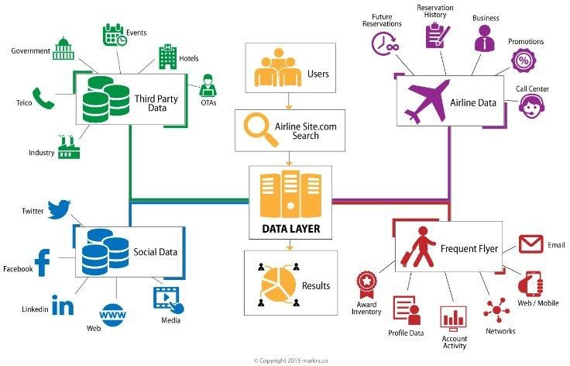

Table-1: Components & Technologies:

|  |  |  |  |
| --- | --- | --- | --- |
| **S.No** | **Components** | **Description** | **Technology** |
| 1. | User Interface | How user interacts with application.  Example: Mobile App | HTML, CSS, Java Script, Excel |
| 2. | Application Logic-1 | Logic for a process in the application | IBM Watson STT service, Python |
| 3. | Application Logic-2 | Logic for a process in the application | IBM Watson Assistant |
| 4. | Database | Data Type, Configurations | MySQL, NSQL |
| 5. | Cloud Database | Database service on cloud | IBM DB2, IBM  Cloudant |
| 6. | File Storage | File Storage requirements | IBM Blocks Storage or  other storage service or Local File system |
| 7. | External API-1 | Purpose of External API used in the application | IBM Weather API |
| 8. | External API-1 | Purpose of External API used in the application | Aadhar API |
| 9. | Infrastructure (Server/Cloud) | Application Deployment on Local System/Cloud Local Server  Configuration: Cloud Server Configuration | Local, Cloud Foundry |

Table-2: Application Characteristics:

|  |  |  |  |
| --- | --- | --- | --- |
| **S.No** | **Characteristics** | **Description** | **Technology** |
| 1. | Open-Source Frameworks | List the open-source frameworks used | Technology of open- source framework |
| 2. | Security Implementations | List all the security/access  controls implemented, use of firewalls. | Example: SHA-256, Encryption, IAM Controls, OWASP |

|  |  |  |  |
| --- | --- | --- | --- |
| 3. | Scalable Architecture | Justify the scalability of architecture | Cognos Used |
| 4. | Availability | Justify the availability of application (e.g: use  of load balancers, distributed servers) | AWS Used |
| 5. | Performance | Design consideration for the performance of the application (number of requests per second, use of  Cache, use of CDN’s) | Dashboard,Reports,Stories |